Performance Review Process

General Notes
The annual performance review deadline is March 31, 2023.

Initiate/Launch Review
P&S - The employee launches the online performance review form in Self Service (My Career > Career & Performance > Performance Review), completes their self-review, and then sends it to their supervisor (Submit Performance Review).
Or alternatively, the supervisor initiates the review form, and then sends the form to the employee to begin working on it (Send to Employee for Comments). The supervisor and employee should review the previous year’s goals to prepare. The supervisor should share details about the performance review process when scheduling the review. The supervisor is encouraged to ask the employee to complete their self-review well in advance of the meeting to allow time to review and prepare for the discussion.
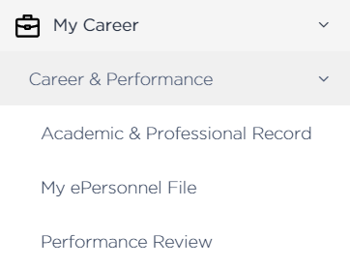
Merit - The supervisor initiates the form for Merit employees by selecting the Create New Review button on the left side of the page in the performance review tool. Merit employees do not have access to the performance review until the acknowledgement step, so the supervisor should provide a self-assessment form to the employee so they can complete it and share it with the supervisor prior to the discussion.
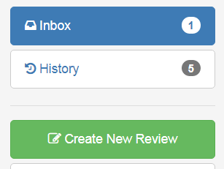

Employee Self-Review
P&S - The employee enters comments in the performance review tool, including the Universal Competencies, Employee Goals & Accomplishments and Employee Additional Comments sections. The employee has two options for entering next year’s goals. They can:
1) enter them directly in the Employee Additional Comments section; or
2) upload them as an attachment by dragging and dropping into the Employee
Performance Documents section.
When finished, the employee sends the review form to the supervisor by selecting the Submit Performance Review button at the bottom of the online form.
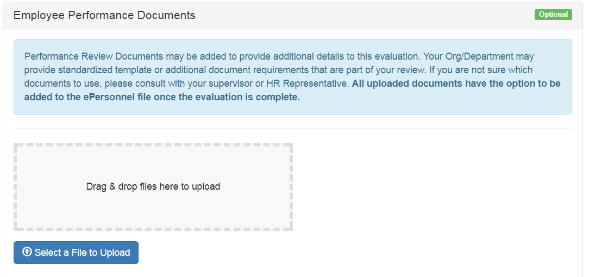
Merit - Merit employees do not have access to the performance tool until the acknowledgement step, so the supervisor should provide a self-assessment form to the employee so they can complete it and share it with the supervisor prior to the discussion.

Request Feedback (OPTIONAL)
P&S and Merit - A performance review best practice is to get feedback from direct reports - and others, as appropriate – for all staff who supervise others. Feedback can also be useful for non-supervisory staff. A discussion with the employee about who they would like to ask for feedback is a collaborative and transparent way to decide upon a list of feedback providers. The Request Feedback feature in the performance review is the method for soliciting feedback from others who work with or are served by the employee.
To ensure useful feedback, provide guidance on the type of feedback you are interested in receiving, and seek feedback that is based on observable behavior. An example of a helpful feedback prompt is, “Please describe your personal observations of (employee’s) strengths and areas for development related to their ability to guide your development.” This is specific enough to yield helpful and actionable information and encourages the person providing feedback to cite actual situations and behaviors.
Be sure to prepare your employee for this practice; do not let it be a surprise.
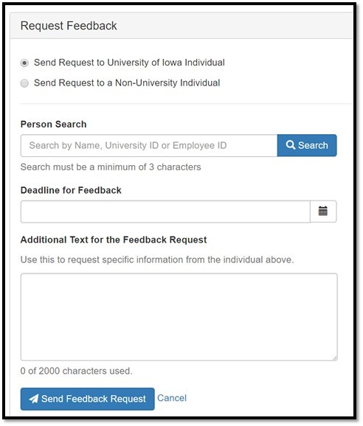

Supervisor Comments & Rating
NEW for the 2022-23 Performance Review Period
A new section has been added to the annual performance review for employees with effective work arrangements, as recommended in the Future of Work@Iowa Report. Supervisors will be asked to respond to the following statement:
This employee’s current work arrangement has been reviewed and is satisfactory. Work arrangements include remote and hybrid and/or a flexible schedule.
The first selection will be tailored for two different scenarios:
Scenario #1: The employee’s work arrangement has NO end date or has an end date after 3/31/24; the following will appear.
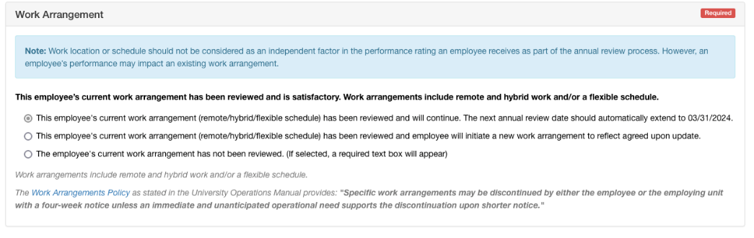
Scenario #2: The employee’s work arrangement has an end date prior to next annual performance review period deadline (3/31/24).
In this scenario, the current end date will be used to auto-populate the last possible review date for this arrangement; the following will appear.
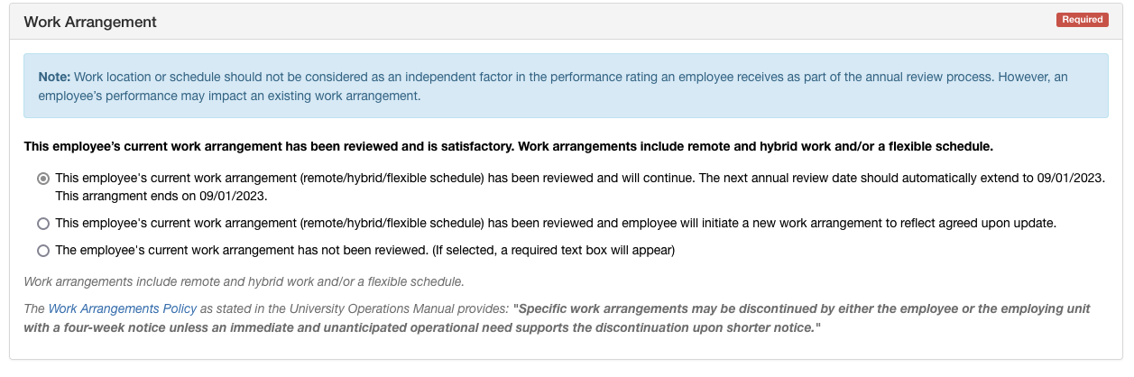
**Selection two and selection three in both above scenarios have no modifications.**
P&S - Following receipt of the employee’s self-review, the supervisor enters comments and feedback in the form. The supervisor may also review, respond to, and edit next year’s goals in advance of the performance discussion.
Note: The employee will not see any supervisor comments until the Employee Acknowledgement step, but the supervisor will be able to see any information entered in the review tool by the employee. The form can be sent back and forth between the employee and supervisor as many times as necessary to facilitate editing and/or changing comments or attachments. A print option is available by selecting the Print Review button on the left side of the page in the performance tool. This is useful if you want to share a draft with the employee during the conversation.
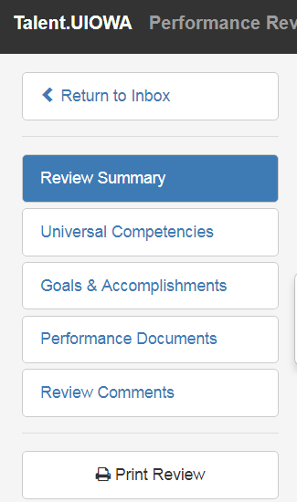

STOP: The supervisor and the employee meet to discuss and review before sending the form on to the Employee Acknowledgment (final) step.
After the performance review discussion between the employee and supervisor, the supervisor can make additional edits and then finalize the review. Selecting the Finalize Review & Send for Acknowledgement button at the bottom of the performance review will complete the review and send it to the employee for their signature.
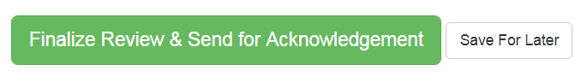
Merit - The supervisor enters comments related to Universal Competencies, Employee Goals & Accomplishments and Supervisor Comments, and can attach the employee’s self-review, and any other additional documentation. Do not use the No Rating option. A print option is available for sharing a draft with the employee during the conversation.
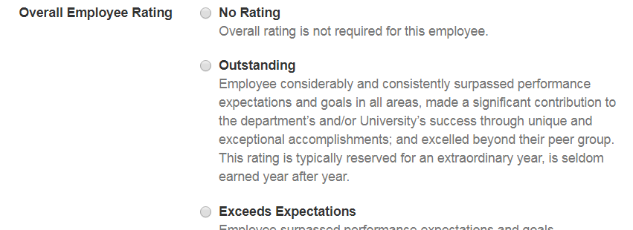
STOP: The supervisor and the employee meet to discuss and review before sending the form on to the Employee Acknowledgment step.
After the performance review discussion between the employee and supervisor, the supervisor can make additional edits and then finalize the review. Selecting the Finalize Review & Send for Acknowledgement button at the bottom of the performance review will complete the review and send it to the employee for their signature.

Employee Acknowledgement
P&S and Merit - The employee reviews the information sent to them by their supervisor and can provides final comments (optional). The employee then signs the review. A copy of the performance review will be automatically uploaded to the employee’s ePersonnel file, and the performance review process is complete.

