LOCAL JOB DESCRIPTION UPDATE GUIDE
Office of the Provost (Org 02) & University College (Org 35)

PURPOSE:
In light of the upcoming performance review cycle ending March 31st, 2023, we are asking for your help in updating your local job description (LJD). This will ensure that we have accurate staff records and allow for easy annual updates, as needed.

HOW TO COMPLETE:
We acknowledge that updating all job descriptions will require some focused attention from you, so we have streamlined the process by including all the relevant information in this guide which contains the following:
- Step by Step Guide to Complete (pages 2-5)
- Example Template (page 6)
- Blank Template for you to fill out and return (page 7)
- Frequently Asked Questions (page 8)

TIMELINE:
Our goal is to complete this review and update in phases.
- Phase 1: Complete and return page 7 of this guide to prov-uc-hr@uiowa.edu no later than March 31, 2023
- Phase 2: Our HR team will take what you provide, put it into our official LJD template and add to your e-personnel file.
- Phase 3 (OPTIONAL): When we finalize your completed LJD, we will add the standard technical competencies that are associated with your job code. We recognize that these may not be all encompassing so as an optional last step, we will have an additional guide on how to expand/update those.
** If you think you already have a recent job description on file, please refer to the FAQ on page 8 for additional information**

Steps to Complete

Access ePersonnel File
- Log into your Employee Self Service which can be found at (https://hris.uiowa.edu/).

- Select the “My Career” tab.
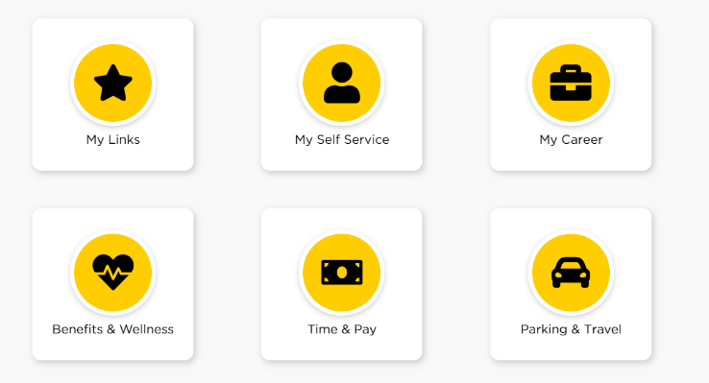

- This should open another screen where you can select “My ePersonnel File” to access your information.
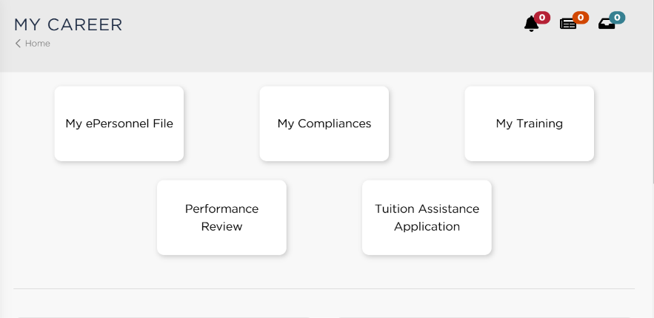

Access University Classification and KARs
- On your ePersonnel home page, click the link next to your “Title.” See below for an example:
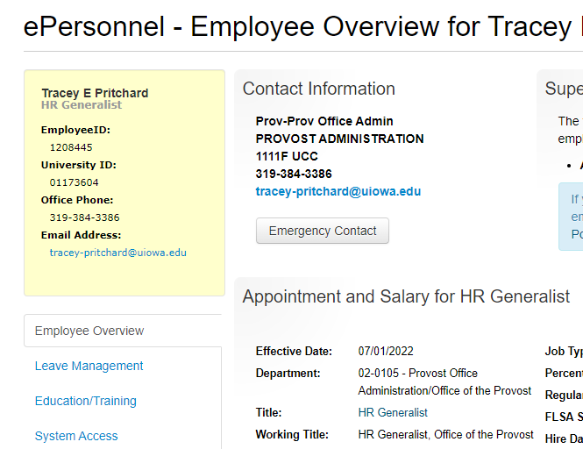
- This will bring you to a page that outlines your University Job Classification, including Key Areas of Responsibility (KARS) (yellow), University Competencies (blue) and Job Technical Competencies (green). You will only need to update the KAR’s for this phase of the update.
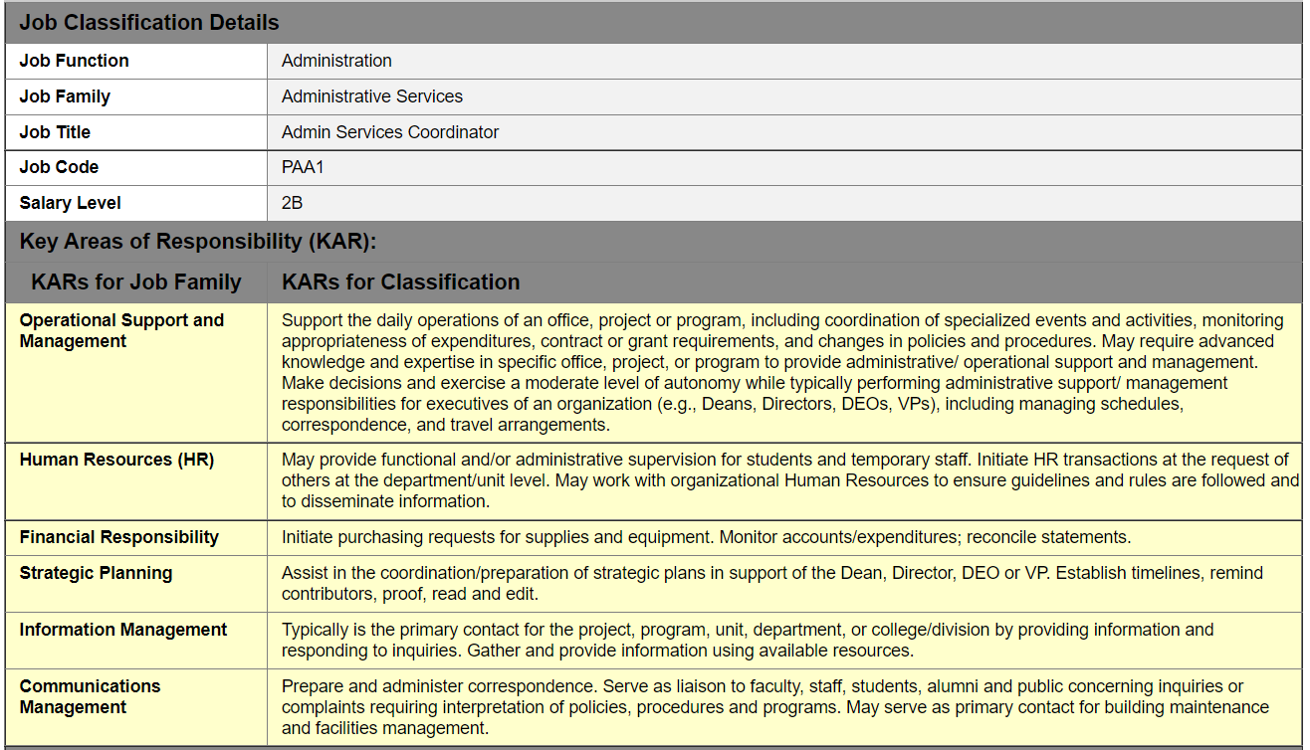

Completing the Template
- Go to page 7 and fill out the top section of the blank template provided with your name, job code, and working title of your position. Job codes can be found at the top of the University Classification page. Working titles do not have to match the job title listed on the University Classification page but can if they accurately describe your position.
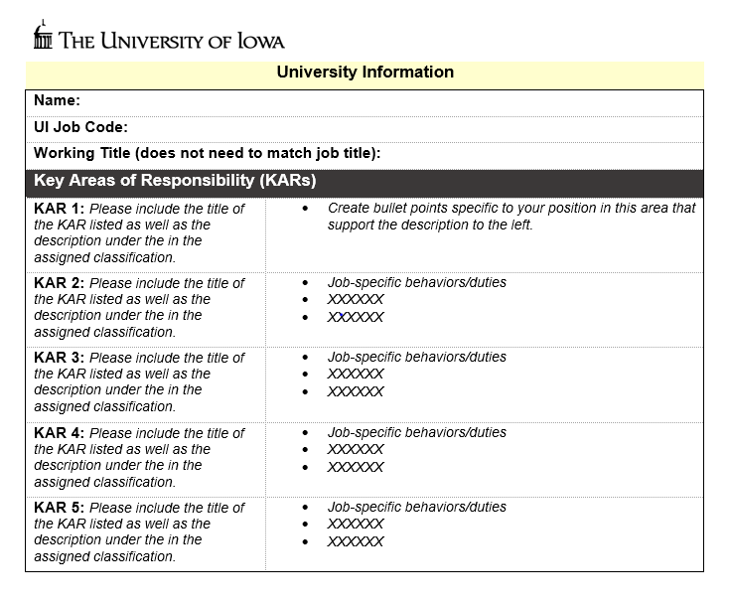
- Copy and paste the KARs into the left column of the blank template provided. Please refer to page 6 for an example template, if helpful to get started. Some helpful tips…
  - Typically, each job description contains 3-5 KARs.
  - Exclude KAR’s that do not account for at least 5% of the work unless the responsibility that falls under it is critically important.
    - For example, your job code may include 5 KARs but only 3 are applicable to your specific position.
  - It is possible that your specific position should include a KAR from another classification… this is fine as long as the majority or primary duties still fall under KARs in the assigned classification. If you think this applies to you, feel free to reach out to our team and we can provide some additional guidance.
- In the right-side columns, create bullet points to describe your duties and responsibilities that fall under each KAR listed on the left. Tips for describing job duties & responsibilities can be found within step 4 of this link: https://hr.uiowa.edu/pay/compensation-classification/positions-descriptions
- After completing your template, please email page 7 to our HR team at prov-uc-hr@uiowa.edu. Your answers will be put into an official job description and uploaded to your ePersonnel file where you can access.

EXAMPLE Template
We have included a completed sample template, for reference.
University Information
Name: Herky Hawkeye
UI Job Code: PAA1
Working Title (does not need to match job title): Administrative Services Coordinator
Key Areas of Responsibility (KARs)
KAR 1: Operational Support and Management  Support the daily operations of an office, project, or program, including coordination of specialized events and activities. May require advanced knowledge and expertise in specific office, project, or program to provide administrative/ operational support and management. Make decisions and exercise a moderate level of autonomy. | - Serve as main point of contact for day-to-day office operations  - Coordinate central office events  - XXXXX  - XXXXX
KAR 2: Information Management  Typically is the primary contact for the project, program, unit, department, or college/division by providing information and responding to inquiries. Gather and provide information using available resources. | - Develop and prepare reports as requested by campus partners  - XXXXXX  - XXXXXX
KAR 3: Communications Management  Prepare and administer correspondence. Serve as liaison to faculty, staff, students, alumni and public concerning inquiries or complaints requiring interpretation of policies, procedures and programs. May serve as primary contact for building maintenance and facilities management. | - Monitor phone and email communications and refer to appropriate campus resources  - Respond to routine inquiries  - XXXXXX  - XXXXXX

Blank Template
Complete and return this page to prov-uc-hr@uiowa.edu no later than March 31, 2023.
University Information
Name:
UI Job Code:
Working Title (does not need to match job title):
Key Areas of Responsibility (KARs)
KAR 1: TITLE OF KAR  Please include the title of the KAR listed as well as the description next to it in the assigned classification. | - Create bullet points specific to your position in this area that support the description to the left.  - XXXXX  - XXXXX
KAR 2: TITLE OF KAR  Please include the title of the KAR listed as well as the description next to it in the assigned classification. | - Job-specific behaviors/duties  - XXXXXX  - XXXXXX
KAR 3: TITLE OF KAR  Please include the title of the KAR listed as well as the description next to it in the assigned classification. | - Job-specific behaviors/duties  - XXXXXX  - XXXXXX
KAR 4: TITLE OF KAR  Please include the title of the KAR listed as well as the description next to it in the assigned classification. | - Job-specific behaviors/duties  - XXXXXX  - XXXXXX
KAR 5: TITLE OF KAR  Please include the title of the KAR listed as well as the description next to it in the assigned classification. | - Job-specific behaviors/duties  - XXXXXX  - XXXXXX

Frequently asked questions
- What is a KAR?
  - These are your key areas of responsibility (KAR) within your position.
  - Typically, a job description includes 3-5 KARs, with 5-7 bullets describing your job duties/responsibilities under each.
- How do you write a job duties?
  - As listed on page 5, the university has several resource pages to help you get started. You can find most of them HERE.

- Do you have a description on file for me?
  - We can double check for you! It is very possible we do not have one on file or it is outdated, but we are happy to check and provide that if it is available.
- I was hired in the last few years or recently updated my job description…. do you need me to do this?
  - You should be able to find your recent job description in your ePersonnel under “Documents.” However, we would like you to complete this form so we can ensure we have the most up-to-date duties on file for your role. Feel free to use your prior description to fill it in!
- I’m overwhelmed by this and not sure where to start!
  - Email prov-uc-hr@uiowa.edu to set up a 15-minute meeting with us! We are happy to help get you on the right path.

- Remind me when this is due again?
  - Please complete and return page 7 of this guide to prov-uc-hr@uiowa.edu no later than March 31, 2023.

