For Our Supervisors/Managers – HR webpage

October 2021 - Good Leaders May Not Be Popular
As we finish out October and the annual performance review process (wink wink), you may have had grace and accountability on your minds. With the tumultuous year + many of us have moved into a place of comfort (forced or chosen) with change, adaptation, and giving grace to those around us. Workplaces are understaffed or under-skilled (new-hires), resources are limited, and various factors often keep tensions high.
Yet we still have to do our jobs, working to meet or exceed standards, and set best practices. The role of the supervisor calls upon our greatness, our humility and our empathy. And within that context, the consistent and ongoing need and expectation for accountability, of ourselves and our team.
Living in a high-state of accountability isn't for everyone. But my job as a leader is to call you up to it and invite you there often. - Alex Dorr, Reality Based Leadership
And the truth is, that in calling your team to greatness, in holding them accountable, they may not love you for it. But if you do, if you encourage a consistent high-state of accountability in yourself and your employees, you'll receive better results, report higher engagement in the workplace, AND most staff in a high-state of accountability report being happier each day, as well.

*Accountability is a mindset, not a skill!
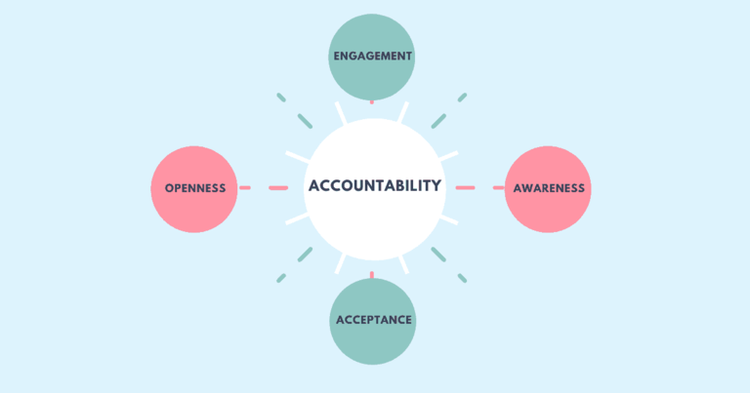
Unfortunately, there's a fair number of employees who default to excuse-based thinking, blaming, or citing circumstances for reasons they can't succeed, especially in tough times. This means they live in a low-state of accountability.
And in your supervisory role, if you're worried about being popular then you're likely to tailor your leadership to please the low-state employees which often results in upsetting your high-state employees. You cannot please both.
John Miller is the author of "The Question Behind the Question". He shares that key words indicate when a question is coming from a victim context and not a place of accountability, such as "why", like "why doesn't anyone tell me anything?" and "why do things keep changing?". The problem is that these questions give control of another person, which decreases happiness.
John Miller says that accountability questions:
- Start with "what" or "how"
- Must include the word "I"
- End with some action verb.
A great question we can ask ourselves (or ask others to ask themselves) to restore accountability is "How can I help?"
In calling your team to greatness and accountability, you may not always be the popular leader; but you'll have a positive and profound impact on the workplace culture and happiness of your team.
Life's Messy, Live Happy!
-Cy Wakeman, Reality Based Leadership

Read more here or download this article.
From last month: How to be funny at work, download.

