For Our Supervisors/Managers

It's the Manager!
Our HR team is committed to supporting our supervisors and managers in their personal and professional development. We know the value a great leader brings to the institution and those they lead. Each month we will share themes, tips and resources to use on your path to being the best manager, supervisor, influencer and employee coach you can be.

70 %
MANAGERS INFLUENCE AT LEAST 70% OF EMPLOYEE ENGAGEMENT.
"On the whole, employees say that the quality of their manager is more important than their compensation." - Gallup

GIVE A HIGH FIVE!
Email us or fill out this short form to "High Five" a peer, colleague, supervisor, direct report, leader or other UI staff, for the positive impact they make in your life or department. Big or small, we'll share your note of thanks and recognition monthly and keep a running list so we can look back at the end of this year.
HIGH FIVE SUBMISSION FORM
All recipients receive a special certificate with the submission info and a of thanks, and those who have given permission to share theirs (from December-February) are in the file here. We'll continue to update the file monthly.
High Fives monthly and are an option for all org 02 & 35 supervisors and staff!
Check out some highlights from the High Five's received thus far on our Rewards and Recognition page.

September 2021 - Feedback and Humor (not so separate)
On the heals of the August 2021 topic of performance reviews (due 10/31/21) and management I did some research on the effects of feedback for hybrid workers. In my quest for information I also attended a conference session and articles on using the rules of comedy to engage teams.

And what better way to relieve tensions from performance and feedback conversations than to add a little humor? Laughter is shown to reduce stress, after all.

QUESTION: How are you feeling about hybrid arrangements, particularly in the ability to experience "serendipity moments" in offering feedback to your employees?
Feedback and reviews are key elements of a supervisor's job. In the new hybrid and remote work environments of today and the future, more frequent, five-minute informal "quick connect" meetings are more critical and help employees avoid feeling "out of sight, out of mind".
And what about "walking meetings"? Can these be constructed while some staff are remote? Of course! Take a phone call while on a walk or treadmill; have a virtual coffee chat; keep it casual and light but intentional for coaching. These moments help supervisors evaluate staff without having to observe their work processes or micromanage.
*It's still best practice and recommended to do formal reviews and sensitive feedback in person, when possible. And on that same note, in person meetings should not be reserved solely for formal conversations. However, be warned (and prepare), a manager should be able to have a conversation about performance regardless of the location.
Read more here, or download the article.

Here I go talking about being prepared while this past year "taught us that we're not working with a script!"
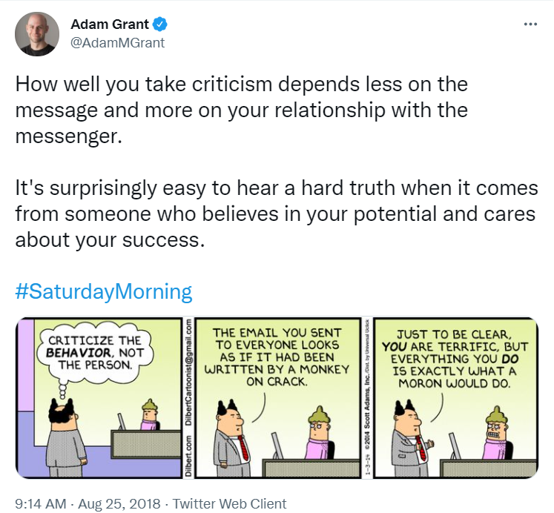

Check out these four RULES of COMEDY can help managers ensure that employees feel valued and safe sharing their ideas in the workplace:
- Be willing to be vulnerable. "Connection happens when someone shares their authentic self." "Your team appreciates it when you humanize yourself. Adding a level of levity to the workplace also helps reduce stress."
- Think like an ensemble. Improv is based on the concept that "all of us are better than one of us," so "seek out diverse perspectives and let those voices be heard". Celebrating and empowering others is a skill set that can help managers be effective and it needs to be practiced.
- Listen completely. "Listening is the willingness to be changed." "Real listening is being open to what you hear and letting it impact your response."
- Create safe spaces. "To engage employees, you need an environment where everyone feels safe to contribute." You may have heard this idea more in recent years - "Improv uses the phrase "yes, and" to build positive dialogues." "You affirm what someone else says and build upon it rather than shutting an idea down,"
Read more here or download the article.
BONUS: How to be funny at work, download.
From last month: 5 Growth Conversations to engage and retain your employees - infographic

Additional

Continued from Aug - Oct, Performance DOCUMENTS:

2021 Annual Performance Reviews Notification Email
Steps for P&S Performance Review Process
Steps for Merit Performance Review Process
Goal Plan Template (optional)
Accomplishments and Goals Template (optional)
Merit Self Evaluation Template
(Recently archived Supervisor/Manager HR pages: Aug '21, July '21, June, '21, May '21, April '21, March '21, Feb '21, Jan '21. Email emily-kleinmeyer@uiowa.edu for older page archives.)

How to Be a Better Human series
CLICK HERE TO CHECK OUT THE ARTICLE SERIES

WORKING, LEARNING AND LEADING REMOTELY
Resources for employees, supervisors and leaders to effectively and efficiently work with hybrid and remote teams.
REMOTE WORK RESOURCES

HYBRID/REMOTE WORK: TIPS for SUPERVISING
As we move to more hybrid work schedules (partially remote) below are some tips and help for supervisors and depts. These considerations are to guide you as you determine the people and positions that are suited for remote work and how to refresh and update your supervision and group work structures. There is content for professional and student staff as well as the link to the flexible work agreement form, for those who are requesting ongoing remote schedule, work or location agreements.
The ICON course: Leading Remote/Hybrid Teams (#WCVD02) training required for current supervisors has some excellent tips, resources, advice and requirements.
*CHECK OUT THE updated UI resource page: Working, Learning and Leading Remotely.
*For Enhanced/Promoting Employee Engagement - Try the platform 15Five.
- The HR team has tested it out and found that the free version offers a user-friendly weekly check-in that asks key questions for keeping staff engaged and motivated, shares that with their supervisor, and promotes further engagement with features like teams, survey options and virtual "high fives" to recognize teammates. (Emily has an account and can add you easily - reach out to learn more!)
- LinkedIn Learning courses: Managing Virtual Teams, Leading at a Distance, Learning Path for Remote Working: Setting Yourself and Your Team up for Success.
Remote Work Considerations and Tips.pdf
Tips for Supervising Students Remotely .pdf
Flexible Work Agreement form - employees should fill this out if they are remaining remote when they could/are asked to return to campus or will have an ongoing flexible arrangement (i.e. hours, duties, location) outside of what the pandemic is currently dictating for depts.
Understanding and Managing Remote Workers - GALLUP RESOURCES
Referenced Resources from ICON Supervisor Training
Resolving Coworker Conflict of Coping with COVID

UI Resources and Programs
Leadership Development is an ongoing effort at the University of Iowa and in our Orgs. The UI Organizational Effectiveness and Learning and Development teams are hard at work creating, updating and enhancing many training and development opportunities for leaders at all levels and supervisors, current and prospective. Check out the links below.
Leadership Development
- Program review and comparison
- Resources
- Elevate - In partnership with Corridor Women Connect, an external opportunity
Leadership Competency Framework
Supervisor Training@Iowa
Supervisor Toolbox
Supervisor Guide to Onboarding

Your Org HR Team
Many of you are familiar with Clifton Strengths and the philosophy of positive psychology. In May 2019, Gallup launched the new book IT'S THE MANAGER by Jim Clifton and Jim Harter, packed with 52 discoveries from Gallup's largest study on the future of work. Your HR team is hard at work tailoring a workshop for supervisors to walk through and learn to apply the strengths-based philosophy to your regular supervisory and coaching strategies. Feel free to reach out with thoughts or preferences on what this might look like and we'll be in touch when we've got a draft/plan to share!

External Development/Training Opportunities
- Individual and Team Performance (ITP) Metrics Lab - Free team assessments to help you learn about each other and improve or enhance your teamwork! Area to assess include leadership, peer feedback, team dynamics, conflict style, and personality. These activities and following discussion can be a great teambuilder.
- People Manager Qualification Program from SHRM.org. Designed to help supervisors develop skills for successfully managing teams, Elle - a virtual character in the program, will help you through an interactive, gamified and edutainment focused virtual learning experience to build solid people and team leadership skills.
- Tune into the recent Gallup webcast on Building Resilience: How Managers Lead Post-Crisis Performance, focused on employee engagement.
- Boss to Coach One - Virtual Training from Gallup to accelerate performance through conversations and coaching.
- Check out Reality-Based Leadership, a philosophy developed by Cy Wakeman, self-proclaimed drama researcher and renowned speaker. Her research has shown that the average employee spends nearly 2.5 hours per day in drama and she made it her mission to support today's leadership on a mission to reduce drama and increase employee accountability. These changes, in turn, increase productivity, employee engagement and satisfaction.
- For Leaders: Lead in Uncertainty and Crisis. A new 2 hour webinar for leaders.
Featured Articles: Why Managers Need Leadership Development

Frequent Resources for Page Content
Gallup.com/workplace
Shrm.org/ResourcesAndTools/hr-topics
Cupahr.org/magazine/
Realitybasedleadership.com/category/leadership/
Follow Emily on LinkedIn!

