For Our Supervisors/Managers

It's the Manager!
Our HR team is committed to supporting our supervisors and managers in their personal and professional development. We know the value a great leader brings to the institution and those they lead. Each month we will share themes, tips and resources to use on your path to being the best manager, supervisor, influencer and employee coach you can be.

70 %
MANAGERS INFLUENCE AT LEAST 70% OF EMPLOYEE ENGAGEMENT.
"On the whole, employees say that the quality of their manager is more important than their compensation." - Gallup

GIVE A HIGH FIVE!
Email us or fill out this short form to "High Five" a peer, colleague, supervisor, direct report, leader or other UI staff, for the positive impact they make in your life or department. Big or small, we'll share your note of thanks and recognition monthly and keep a running list so we can look back at the end of this year.
HIGH FIVE SUBMISSION FORM
All recipients receive a special certificate with the submission info and a of thanks, and those who have given permission to share theirs (from December-February) are in the file here. We'll continue to update the file monthly.
High Fives monthly and are an option for all org 02 & 35 supervisors and staff!
Check out some highlights from the High Five's received thus far on our Rewards and Recognition page.

June 2021 - Bad Habits and Burnouts
Now that we're all aware of what sensemaking is (from May page content) and ready to apply it, how about the connection of bad habits and burnout?
A message that has been encouraged throughout the pandemic and thrust upon us even more as we work to create a new normal, is to focus on what we've learned about ourselves, and in the world of work, about our teams. Many staff have been able to prove they can continue to be productive away from the physical work site and some have thrived. In addition, some remote staff have, unfortunately, developed some bad habits along the way. As we are navigating the transition for many to return to campus, with some remote or hybrid work continuing, it will be necessary to identify and address behaviors that limit productivity or are unprofessional. Do you have any of these folks on your team?
- The Recluse.

  - Rarely if ever uses video or audio on team meetings/calls.
  - Low participation in meetings.
  - Unclear if they're listening or ignoring/multi-tasking.
  - WHAT TO DO: Update your ground rules. Seek comments from each team members. Ask direct questions. Consider break out groups.
- The Slacker.
  - Requires extra attention and reminders.
  - Missing deadlines.
  - Late to respond.
  - WHAT TO DO: Have a 1:1 meeting to discuss the performance decline and possible improvement options. Ensure they understand possible consequences if improvement is not attained.
- Poorly Groomed.
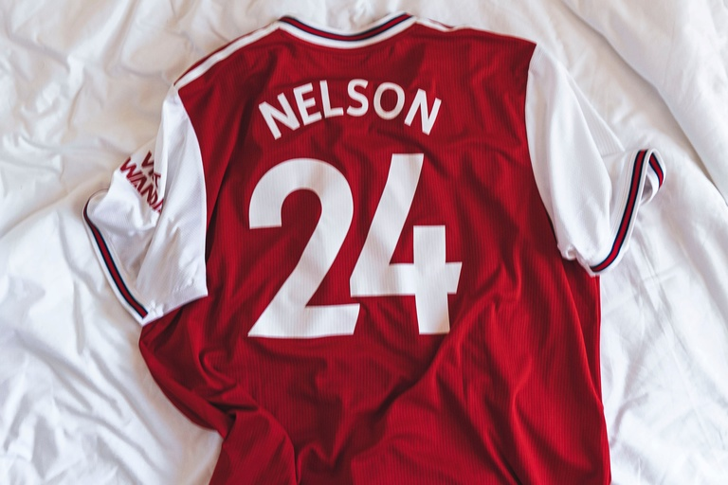

  - Pushing "business casual" to the limit.
  - Unprepared for larger, senior level or important meetings.
  - Consistent or declining unprofessional appearance.
  - WHAT TO DO: Ensure employees know when executives will be in attendance or which meetings should be considered important. Share what you consider to be appropriate appearance for all attending those meetings.
- The Juggler.
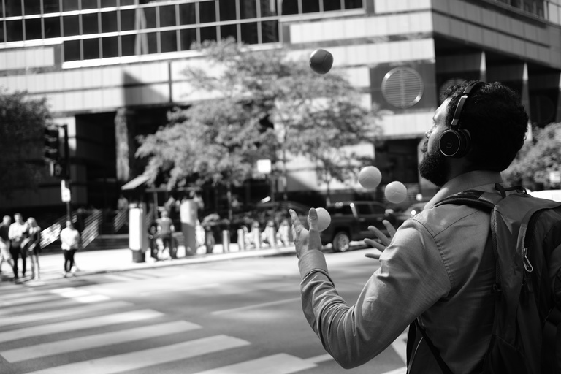
  - Unfocused in meetings.
  - Multi-tasking during meetings.
  - Caught off guard when asked a question.
  - WHAT TO DO: Set firm expectations of when employees should be working. Communicate that multi-tasking can get a lot done but not always at the highest quality. Prioritize tasks to help them manage time.
- The Distracted.
  - Unable to focus or complete a meeting.
  - Having to switch rooms or jump off and back on a meeting.
  - WHAT TO DO: Offer additional resources such as assistance setting up a desk space (a sit-stand). Have a conversation on how you can help them get focused off-site.

Maybe your employee is exhibiting bad habits or struggling because of burnout. According to Gallup research, "8 in 10 workers experience burnout on the job at least sometimes".
"Burnout has effects on the micro and macro levels. If employees' well-being suffers, they may turn to unhealthy coping mechanisms. They may also become less productive and unfocused.
Managers play a significant role in employees' mental health and can take several approaches to ease the effects of burnout."
Check out the article with tips "How to Douse Chronic Workplace stress Before it Explodes to Full Burnout" below.

How to Douse Chronic Workplace Stress Before it Explodes into Full Burnout
CLICK HERE TO READ THE ARTICLE FROM SHRM.ORG

Additional

FEATURED ARTICLES: How Managers Can Address These 5 Bad Habits of Remote Workers; How to Douse Chronic Workplace Stress Before It Explodes into Full Burnout.

(Recently archived Supervisor/Manager HR pages: June, '21, May '21, April '21, March '21, Feb '21, Jan '21. Email emily-kleinmeyer@uiowa.edu for older page archives.)

How Your Family Life Might Make You a Better Manager
Click here for full article download.
CLICK HERE TO READ THE ARTICLE FROM SHRM.ORG

REMOTE WORK: TIPS for SUPERVISING
As you continue to work fully remote or hybrid below are some tips and help for supervisors and depts. These considerations are to guide you as you determine the people and positions that are suited for remote work and how to refresh and update your supervision and group work structures. There is content for professional and student staff as well as the link to the flexible work agreement form, for those who are requesting ongoing schedule, work or location agreements (not necessary for those continuing remote who have not been requested back to work site yet).
The new ICON course: Leading Remote/Hybrid Teams (#WCVD02) training required for current supervisors has some excellent tips, resources, advice and requirements.
*For Enhanced/Promoting Employee Engagement - Try the platform 15Five.
- The HR team has tested it out and found that the free version offers a user-friendly weekly check-in that asks key questions for keeping staff engaged and motivated, shares that with their supervisor, and promotes further engagement with features like teams, survey options and virtual "high fives" to recognize teammates. (Emily has an account and can add you easily - reach out to learn more!)
- LinkedIn Learning courses: Managing Virtual Teams, Leading at a Distance, Learning Path for Remote Working: Setting Yourself and Your Team up for Success.
Remote Work Considerations and Tips.pdf
Tips for Supervising Students Remotely .pdf
Flexible Work Agreement form - employees should fill this out if they are remaining remote when they could/are asked to return to campus or will have an ongoing flexible arrangement (i.e. hours, duties, location) outside of what the pandemic is currently dictating for depts.
Understanding and Managing Remote Workers - GALLUP RESOURCES
Referenced Resources from ICON Supervisor Training
Resolving Coworker Conflict of Coping with COVID

UI Resources and Programs
Leadership Development is an ongoing effort at the University of Iowa and in our Orgs. The UI Organizational Effectiveness and Learning and Development teams are hard at work creating, updating and enhancing many training and development opportunities for leaders at all levels and supervisors, current and prospective. Check out the links below.
Leadership Development
- Program review and comparison
- Resources
- Elevate - In partnership with Corridor Women Connect, an external opportunity
Leadership Competency Framework
Supervisor Training@Iowa
Supervisor Toolbox
Supervisor Guide to Onboarding

Your Org HR Team
Many of you are familiar with Clifton Strengths and the philosophy of positive psychology. In May 2019, Gallup launched the new book IT'S THE MANAGER by Jim Clifton and Jim Harter, packed with 52 discoveries from Gallup's largest study on the future of work. Your HR team is hard at work tailoring a workshop for supervisors to walk through and learn to apply the strengths-based philosophy to your regular supervisory and coaching strategies. Feel free to reach out with thoughts or preferences on what this might look like and we'll be in touch when we've got a draft/plan to share!

External Development/Training Opportunities
- Individual and Team Performance (ITP) Metrics Lab - Free team assessments to help you learn about each other and improve or enhance your teamwork! Area to assess include leadership, peer feedback, team dynamics, conflict style, and personality. These activities and following discussion can be a great teambuilder.
- *New People Manager Qualification Program from SHRM.org. Designed to help supervisors develop skills for successfully managing teams, Elle - a virtual character in the program, will help you through an interactive, gamified and edutainment focused virtual learning experience to build solid people and team leadership skills.
- Tune into the recent Gallup webcast on Building Resilience: How Managers Lead Post-Crisis Performance, focused on employee engagement.
- Boss to Coach One - Virtual Training from Gallup to accelerate performance through conversations and coaching.
- Check out Reality-Based Leadership, a philosophy developed by Cy Wakeman, self-proclaimed drama researcher and renowned speaker. Her research has shown that the average employee spends nearly 2.5 hours per day in drama and she made it her mission to support today's leadership on a mission to reduce drama and increase employee accountability. These changes, in turn, increase productivity, employee engagement and satisfaction.
- For Leaders: Lead in Uncertainty and Crisis. A new 2 hour webinar for leaders.
Featured Articles: Why Managers Need Leadership Development

Frequent Resources for Page Content
Gallup.com/workplace
Shrm.org/ResourcesAndTools/hr-topics
Cupahr.org/magazine/
Realitybasedleadership.com/category/leadership/
Follow Emily on LinkedIn!

